Ideation Phase
Brainstorm & Idea Prioritization Template
Date
Team ID
Project Name | Incident Lifecycle Automation in ServiceNow
Maximum Marks | 4 Marks

Brainstorm & Idea Prioritization:
Brainstorming provides a free and open environment that encourages everyone within a team to participate in the creative thinking process that leads to problem solving. Prioritizing volume over value, out-of-the-box ideas are welcome and built upon, and all participants are encouraged to collaborate, helping each other develop a rich amount of creative solutions.
For this project, the brainstorming activity focuses on identifying practical ways to standardize and automate the Incident Management lifecycle in ServiceNow, from incident creation and classification through investigation, resolution, knowledge creation, and final validation.

Step-1: Team Gathering, Collaboration and Select the Problem Statement
The team discussed the current incident-management challenges described for the project and identified the need for a structured ServiceNow-based lifecycle. The discussion focused on inconsistent incident recording, classification, ownership, delayed escalation, limited SLA visibility, and difficulty tracking related records such as emergency changes and child incidents.
Selected Problem Statement:
How might we standardize and automate the incident lifecycle in ServiceNow so that incidents are consistently created, classified, assigned, investigated, resolved, documented, and validated with clear SLA and related-record visibility?
Key participants represented in the project context: End Users, Service Desk Agents, Level 2 Support, Change Management Team, and ServiceNow Administrator.

Step-2: Brainstorm, Idea Listing and Grouping
The following project-specific ideas were generated from the selected problem statement and grouped around the major activities in the proposed ServiceNow incident lifecycle.
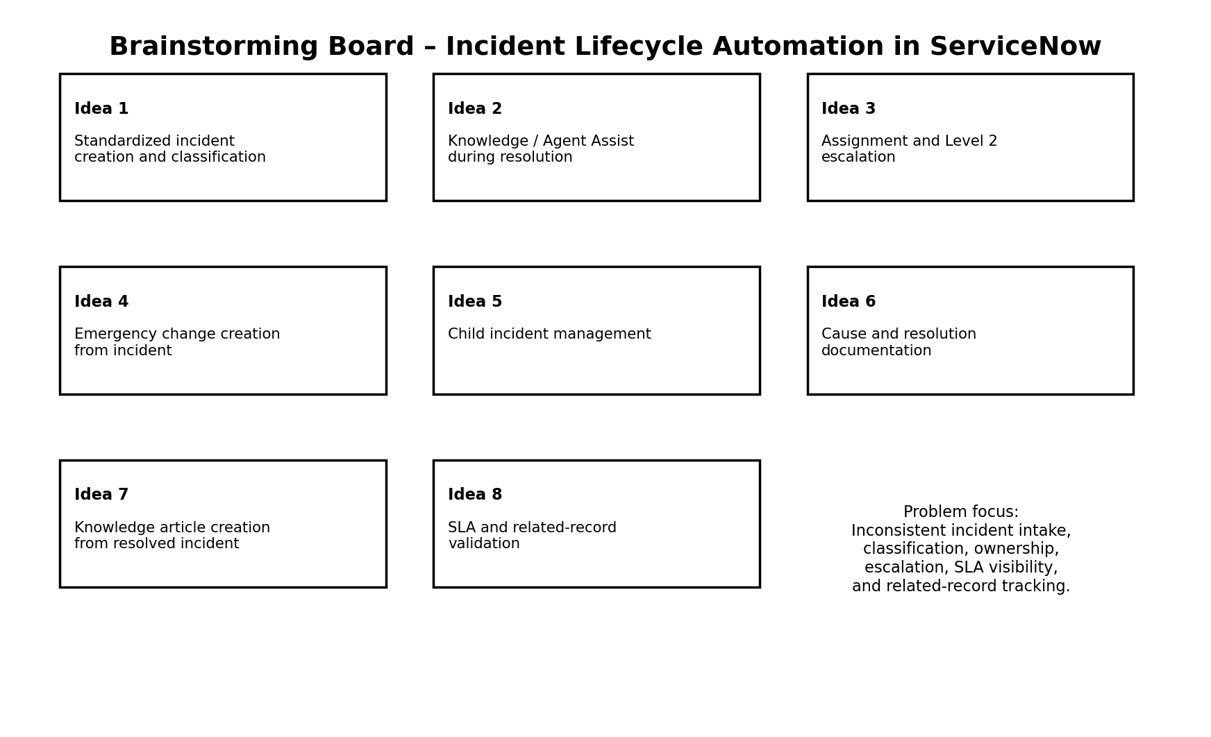
Group | Ideas Included | Project Relevance
Incident Intake & Control | Incident creation; classification; assignment/reassignment | Creates structured ownership and consistent incident records.
Resolution Support | Knowledge / Agent Assist; Level 2 investigation; cause and resolution documentation | Supports investigation and standardized resolution activities.
Related Record Management | Emergency change; child incidents | Connects related operational activities to the incident.
Continuous Knowledge & Validation | Knowledge article creation; SLA and related-record validation | Improves reuse of documented solutions and lifecycle visibility.

Step-3: Idea Prioritization
Ideas were considered using two dimensions from the template: importance to the project objectives and feasibility/practicality within the stated ServiceNow project scope. The matrix below documents the prioritization used to shape the project workflow.
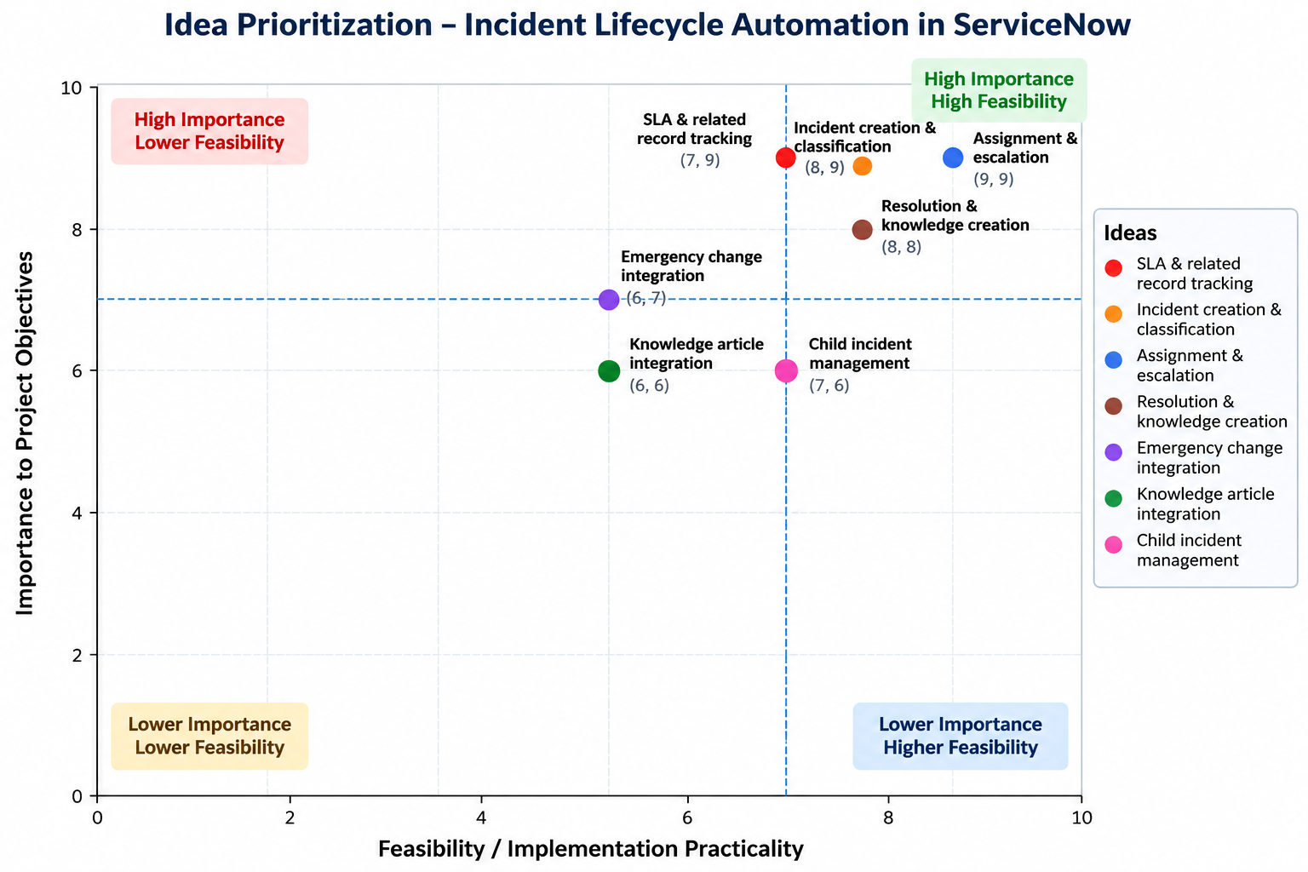
The prioritization indicates that incident creation and classification, assignment and Level 2 escalation, knowledge support, SLA/related-record tracking, and resolution documentation are central to the lifecycle. Emergency change integration, child incident handling, and knowledge article creation are also retained because they address the project's defined scope and related-record requirements.

Idea / Capability | Importance | Feasibility
Incident creation & classification | 9/10 | 9/10
Assignment / Level 2 escalation | 9/10 | 8/10
Knowledge / Agent Assist | 8/10 | 8/10
SLA & related-record tracking | 9/10 | 7/10
Emergency change integration | 7/10 | 6/10
Resolution & cause documentation | 8/10 | 8/10
Child incident management | 6/10 | 7/10
Knowledge article creation | 6/10 | 6/10

Outcome of Ideation: The selected ideas collectively support the defined ServiceNow workflow: Incident Creation → Incident Classification → Knowledge / Agent Assist → Assignment / Reassignment → Level 2 Investigation → Resolution / Related Changes → Child Incident Handling → Incident Closure → Knowledge Article Creation → SLA and Final Validation.

